Little Teddy Knitting Pattern

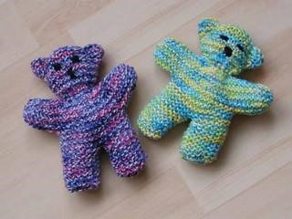

With 4mm needles and Baby Double Knitting.

Garter stitch used throughout (knit every row)

Cast on 8 stitches and work 16 rows.

Break off yarn and cast on 8 stitches and work 16 rows to form other leg.

Knit across both legs (16 sts) and complete 12 rows.

Cast on 8 stitches at beginning of next 2 rows.

Work 8 rows.

Cast off 8 stitches at beginning of next 2 rows.

Now work 38 rows on these 16 sts.

Cast on 8 stitches at beginning of next 2 rows.

Work 8 rows.

Cast off 8 stitches at beginning of next 2 rows.

Work 8 rows.

Using only first 8 stitches, work 16 rows and then cast off.

Return to remaining 8 stitches and work 16 rows and then cast off.

Making up.

Fold knitted piece in half lengthways. The fold becomes the top of the head.

Join seam around teddy, leave a small gap between the legs.

Turn right side out.

Backstitch a diagonal line across corner of head to form ears.

Stuff (with flame resistant stuffing) and slip stitch closed area left for stuffing.

Embroider a face on teddy.

Take a double thickness of yarn and thread around neck, going in every few stitches, (making sure there are no loops that little fingers can get into).

Draw up yard tightly to form neck and secure ends.

Optional scarf

With same needles and thickness of yarn, cast on 60 stitches.

Knit 6 rows and then cast off.

Tie round teddy’s neck and secure in place if being given to a small child.